10.1.11 Editors - Shader Editor - Header - Add Menu - Converter
Detailed table of content 1
Add menu - Converter 4
Blackbody 4
Clamp 4
Color Ramp 5
Combine HSV 7
Combine RGB 7
Combine XYZ 7
Map Range 8
Math 9
RGB to BW 10
Separate HSV 10
Separate RGB 10
Separate XYZ 11
Shader To RGB 11
Vector Math 12
Wavelength 13

Detailed table of content
Detailed table of content
Detailed table of content 1
Add menu - Converter 4
Blackbody 4
Inputs 4
Temperature 4
Outputs 4
Color 4
Clamp 4
Inputs 4
Value 4
Min 4
Max 4
Properties 5
Clamp Type 5
Min Max 5
Range 5
Outputs 5
Result 5
Color Ramp 5
Inputs 5
Factor 5
Properties 5
Color Ramp 5
Controls 5
+ 5
- 5
Tools menu 5
Flip Color Ramp 5
Distribute Stops from Left 5
Distribute Stops Evenly 6
Eyedropper (pipette icon) E 6
Reset Color Ramp 6
Color Mode 6
RGB 6
HSV/HSL 6
Interpolation 6
Ease 6
Cardinal 6
Linear 6
B-Spline 6
Constant 6
Color Ramp 6
Active Color Stop elements 6
Choose active color stop 6
Pos 6
Outputs 7
Image 7
Alpha 7
Combine HSV 7
Input 7
H, S and V 7
Output 7
Color 7
Combine RGB 7
Input 7
R, G and B 7
Output 7
Color 7
Combine XYZ 7
Input 8
X Y and Z 8
Output 8
Color 8
Map Range 8
Inputs 8
Value 8
From Min 8
From Max 8
To Min 8
To Max 8
Properties 8
Interpolation Type 8
Linear 8
Stepped Linear 8
Smooth Step 8
Smoother Step 9
Clamp 9
Outputs 9
Result 9
Math 9
Inputs 9
Value 9
Value 9
Properties 9
Operation 9
Clamp 9
Outputs 10
Value 10
RGB to BW 10
Inputs 10
Image 10
Outputs 10
Value 10
Separate HSV 10
Input 10
Color 10
Output 10
H , S and V 10
Separate RGB 10
Input 11
Image 11
Output 11
R, G and B 11
Separate XYZ 11
Input 11
Vector 11
Output 11
X, Y and Z 11
Shader To RGB 11
Inputs 12
Shader 12
Outputs 12
Color 12
Alpha 12
Vector Math 12
Inputs 12
Vector 12
Vector 12
Scale 12
Properties 12
Operation 12
Outputs 12
Vector 13
Value 13
Wavelength 13
Inputs 13
Wavelength 13
Outputs 13
Color 13

Add menu - Converter
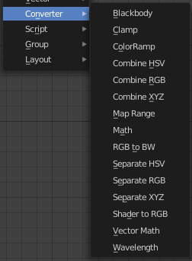
Here you find mainly nodes to convert data to another data.

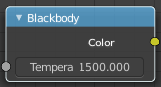
Blackbody
The Blackbody node converts a blackbody temperature to RGB value. This can be useful for materials that emit light at natural occurring frequencies.

Inputs

Temperature
The temperature in Kelvin.

Outputs

Color
RGB color output.

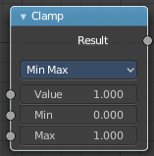
Clamp
The Clamp node clamps a value between a minimum and a maximum.

Inputs

Value
The input value to be clamped.

Min
The minimum value.

Max
The maximum value.

Properties

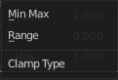
Clamp Type

Min Max
Clamp values using Min and Max values.

Range
Clamp values between Min and Max range.

Outputs

Result
The input value after clamping.

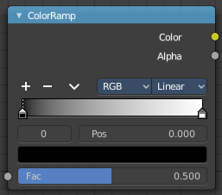
Color Ramp
The Color Ramp Node is used for mapping values to colors with the use of a gradient.

Inputs

Factor
The Factor input is used as an index for the color ramp.

Properties

Color Ramp
Color Ramps enables the user to specify a range of colors based on color stops. The color between the color stops gets interpolated.

Controls

+
Add a stop to your color ramp. The stop will be added after the selected one, in the middle to the next one.

-
Deletes the selected color stop from the list.


Tools menu

Flip Color Ramp
Flips the gradient, inverting the values of the color ramp.

Distribute Stops from Left
Rearrange the stops so that every step has the same space to the right.

Distribute Stops Evenly
Space between all neighboring stops becomes equal.

Eyedropper (pipette icon) E
An Eyedropper to sample a color or gradient from the interface to be used in the color ramp.

Reset Color Ramp

Resets the color ramp to its default state.

Color Mode

RGB
Blends color by mixing each color channel and combining.

HSV/HSL
Blends colors by first converting to HSV or HSL, mixing, then combining again. This has the advantage of maintaining saturation between different hues, where RGB would de-saturate, this allows for a richer gradient.


Interpolation

Ease
Uses an Ease Interpolation for the color stops.

Cardinal
Uses a Cardinal Interpolation for the color stops.

Linear
Uses a Linear Interpolation for the color stops.

B-Spline
Uses a B-Spline Interpolation for the color stops.

Constant
Uses a Constant Interpolation for the color stops.

Color Ramp
The color band. A click at one of the color stops makes it the active one. You can move the color stops by clicking at them and dragging them around.

Active Color Stop elements

Adjust the active color stop.

Choose active color stop
Choose the color stop by index.

Pos
The position of the active color stop. The range goes from 0.000 to 1.000

Outputs

Image
Standard image output.

Alpha

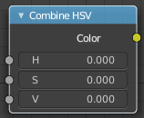
Combine HSV
Combine the single HSV channels into a single image.

Input

H, S and V
The Hue, Saturation and Value channels of an image.

Output

Color
Color output.

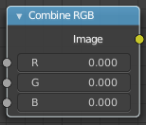
Combine RGB
Combine the single RGB channels into a single image.

Input

R, G and B
The red, green and blue channels of an image.

Output

Color
Color output.

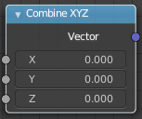
Combine XYZ
Same as with Combine RGB node. It combines color values. But instead combining rgb values, which are in the range of 0 to 255, it uses values in the range from 0 to 1.

Input

X Y and Z
X, Y and Z values.

Output

Color
Color output.

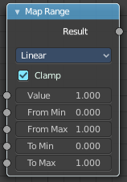
Map Range
The Map Range node remaps a value from a range to a target range.

Inputs

Value
The input value to be remapped.

From Min
The lower bound of the range to remap from.

From Max
The higher bound of the range to remap from.

To Min
The lower bound of the target range.

To Max
The higher bound of the target range.

Properties

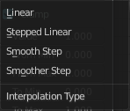
Interpolation Type

Linear
Linear interpolation between From Min and From Max values.

Stepped Linear
Stepped linear interpolation between From Min and From Max values.

Smooth Step
Smooth Hermite edge interpolation between From Min and From Max values.

Smoother Step
Smoother Hermite edge interpolation between From Min and From Max values.

Clamp
If enabled, the output is clamped to the target range.

Outputs

Result
The input value after remapping.

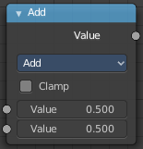
Math
The Math Node performs math operations.

Inputs

Value
First numerical value. The trigonometric functions accept values in radians.

Value
Second numerical value. This value is not used in functions that accept only one parameter like the trigonometric functions, Round and Absolute.

Properties

Operation
Here youcan choose what mathematical operation to perform.
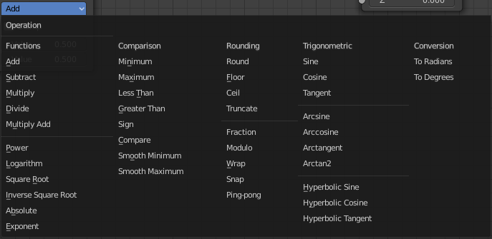

Clamp
Limits the output to the range (0 to 1). See clamp.

Outputs

Value
Numerical value output.

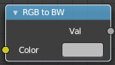
RGB to BW
The RGB to BW Node converts an RGB color image to a gray-scale inage based at its luminance.

Inputs

Image
Color image input.

Outputs

Value
Gray-scale value output.

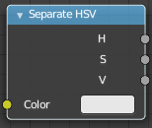
Separate HSV
Combine the single RGB channels into a single image.

Input

Color
Color input.

Output

H , S and V
The Hue, Saturation and Value channels of an image.

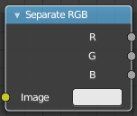
Separate RGB
Combine the single RGB channels into a single image.

Input

Image
The image input.

Output

R, G and B
The red, green and blue channels of an image.

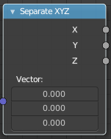
Separate XYZ
Same as with Combine RGB node. It separates color values. But instead separating rgb values, which are in the range of 0 to 255, it uses a vector with the values in the range from 0 to 1.

Input

Vector
The Input vector.

Output

X, Y and Z
The output vectors for X, Y and Z

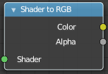
Shader To RGB
Eevee Only
The Shader to RGB node is typically used for non-photorealistic rendering, to apply additional effects on the output of BSDFs. For example, a color ramp on the output of a diffuse BSDF can be used to create a flexible toon shader.
Using this conversion breaks the PBR pipeline and thus makes the result unpredictable when used in combination with effects such as ambient occlusion, contact shadows, soft shadows and screen space refraction.
Some effects require multiple samples to converge, and applying arbitrary changes to noisy input may not convert to a smooth result.
Warning! If a Shader to RGB node is used, any upstream BSDF will be invisible to the following effects: Screen Space Reflection, Subsurface Scattering

Inputs

Shader
Any shader such as a BSDF or Emission node can be linked here.

Outputs

Color
Surface color computed from BSDFs and lighting.

Alpha
Alpha transparency from any Transparent BSDFs in the input.

Vector Math
The Vector Math node performs the selected math operation on the input vectors.

Inputs
The inputs of the node are dynamic. Some inputs are only available in certain operations. For instance, the Scale input is only available in the Scale operator.

Vector
Input vector A.

Vector
Input vector B.

Scale
Input Scale.

Properties


Operation
The vector math operator to be applied on the input vectors.

Outputs
The output of the node is dynamic. It is either a vector or a scalar depending on the operator. For instance, the Length operator have a scalar output while the Add operator have a vector output.

Vector
Output vector.

Value
Output value.

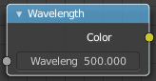
Wavelength
Cycles Only
The Wavelength node converts a wavelength value to an RGB value. This can be used to achieve a specific color on the light spectrum.

Inputs

Wavelength
The color wavelength from 380 to 780 nanometers.

Outputs

Color
RGB color output.

